Lesson 4: How much do you have to push on any object to get it to deform (temporarily vs. permanently)?

Previous Lesson | We made a claim about whether all solid objects change shape when pushed during a collision. We analyzed slow-motion videos, carried out an investigation with a laser and a mirror, and analyzed a concrete joint load testing video. We used these sources of data to argue for whether our original claims are supported or refuted by the evidence
This Lesson  Investigation  2 days   | 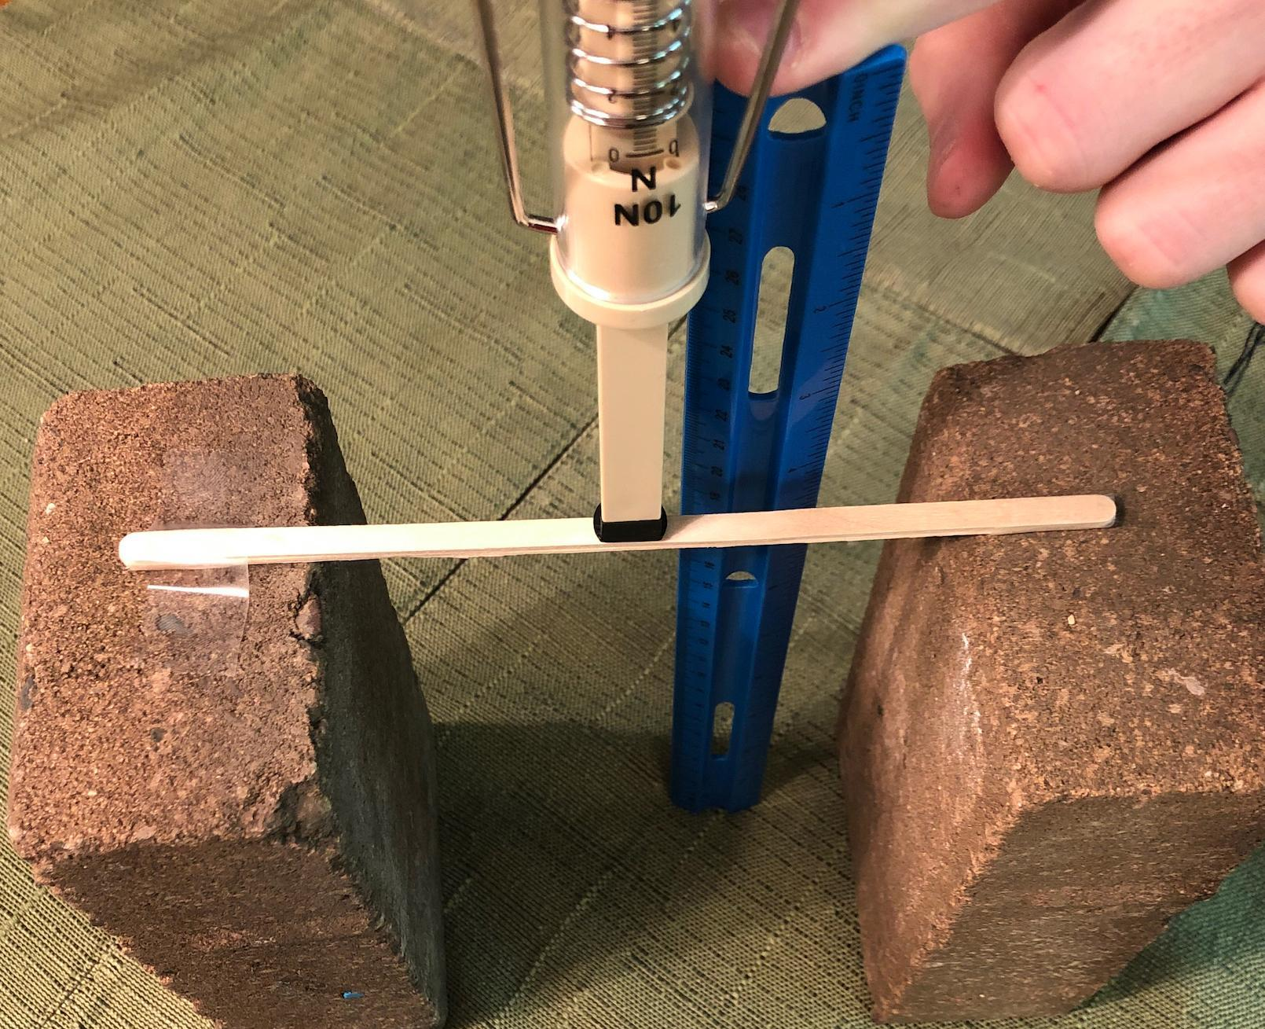 | We plan and carry out an investigation to look at the relationship between contact force applied and the amount of deformation that occurs in different materials. We graph our data and compare these graphs to those from other materials tests. We develop a model to represent the elastic and nonelastic behavior of all solid objects in response to varying amounts of force applied to them.
Next Lesson | We will carry out investigations to explore the strength of forces between two objects when they collide. We will plan and carry out an investigation about how different speeds and masses of objects affect the amount of peak force on each object. We will develop and use a model to represent the relationship between the energy of a moving object and the strength of the peak forces from a collision.

BUILDING TOWARD NGSS  MS-PS2-1, MS-PS2-2, MS-PS3-1, MS-ETS1-2, MS-ETS1-3, MS-LS1-8   | What students will do  4.A Plan an investigation, identifying controls to keep constant, and carry out the investigation to produce data to serve as the basis for evidence to develop a mathematical model for the relationship (pattern) between the amount of force applied to an object and the amount it deforms.  4.B Analyze and interpret graphical data (patterns) from tests of compression force vs. amount and type of deformation (temporary vs. permanent) to provide evidence that supports an argument that all objects behave elastically up to a specific limit beyond which permanent damage occurs (stability and change).  What students will figure out  - All solid objects deform elastically when force is applied to them, up to a point.  - Different objects have different elastic limits, which is the maximum amount of deformation an object can withstand, beyond which it will deform permanently.  - Different objects have different breaking points, which is the maximum amount of deformation an object can withstand, beyond which it will crack or split apart.  - The type of material, the shape, and the thickness of an object all affect (a) how much it deforms when a force is applied to it, (b) its elastic limit and, (c) its breaking point.

Lesson 4 • Learning Plan Snapshot
Part | Duration |  | Summary | Slide | Materials
1 | 4 min |  | NAVIGATION  Reflect on what we figured out in Lesson 3 and consider how to test how much force it takes to bend or change the shape of any solid object any amount (permanently or temporarily). | A
2 | 7 min |  | PLAN AN INVESTIGATION: MATERIAL DEFORMATION LAB  Introduce the materials we will use in the investigation and demonstrate what the push-pull spring scale measures. |  | Material Deformation Equipment Demonstration
3 | 7 min |  | IDENTIFY THE VARIABLES IN THE INVESTIGATION  Discuss what the independent, dependent, and controlled variables would be for this investigation. | B-C | Independent, Dependent, and Controlled Variables, Deformation Results, Investigation Procedures, chart paper, markers
4 | 12 min |  | CARRY OUT THE MATERIAL DEFORMATION LAB  Collect data in the Material Deformation Lab. |  | Independent, Dependent, and Controlled Variables, Deformation Results, Investigation Procedures, impact goggles, Material Deformation Lab
5 | 10 min |  | CONSTRUCT AND COMPARE GRAPHS  Graph data from the Material Deformation Lab and draw and compare trend lines for their data. | D-H | Deformation Results, ruler (or straight edge like a wood stirrer), Example Line of Best Fit
6 | 3 min |  | NAVIGATION  Make predictions about trend lines for other materials tested. | G | Deformation Results

End of day 1
7 | 5 min |  | NAVIGATION  Compare lines of best fit between different materials tested in the class using a jigsaw strategy. | H | Deformation Results
8 | 12 min |  | GATHER INFORMATION  Gather additional information about materials testing. | I-J | Results from other materials tests
9 | 15 min |  | ADD TO OUR PROGRESS TRACKER  Discuss key ideas we figured out in a Consensus Discussion to update the class Progress Tracker. | K
10 | 10 min |  | ARGUING FROM EVIDENCE  Evaluate a claim using evidence. | L
11 | 3 min |  | NAVIGATION  Discuss ideas about collisions in which both colliding objects are moving. | M

End of day 2

Lesson 4 • Materials List
 | per student | per group | per class
Material Deformation Equipment Demonstration materials |  |  | - 2 bricks  - 3 wood stirrers taped together  - a piece of duct tape or cellophane tape  - 1 ruler  - 15 10-N push-pull spring scales  - 1 digital scale
Material Deformation Lab materials |  | - 2 bricks  - 2 or 4 wood stirrers or Styrofoam strips  - 1 push-pull spring scale (10 N)  - 1 metric ruler | - transparent tape  - extra wood stirrers and styrofoam strips (10-15 each)
Lesson materials | - Independent, Dependent, and Controlled Variables  - Deformation Results  - Investigation Procedures  - science notebook  - impact goggles  - ruler (or straight edge like a wood stirrer)  - Results from other materials tests |  | - chart paper  - markers  - Example Line of Best Fit

Materials preparation (20 minutes)

Review teacher guide, slides, and teacher references or keys (if applicable).

Make copies of handouts and ensure sufficient copies of student references, readings, and procedures are available.

Prepare a single class set of Investigation Procedures to reuse across classes.

Make one double-sided copy of Results from other materials tests per student.

If you are using science notebooks (9.75" x 7.5") and you have a paper cutter, trim all handouts to fit in the notebooks.

Make one copy of Example Line of Best Fit to introduce as a reference to add to the Word Wall for all your classes at the end of day 1 of this lesson.

Day 1: Material Deformation Equipment Demonstration
- Group size: whole class
- Setup
- Put two bricks on a lab table, 14 cm apart.
- Bundle and tape 3 wood stirrers together at both ends (using transparent tape).
- Leave a piece of duct tape out for taping one end of the stirrers down to one brick. Regular cellophane tape may work as well.
- Collect a class set of push-pull spring scales (10 N).
- Set out 1 digital scale and 1 ruler.
- Storage: All materials can be stored and reused indefinitely.

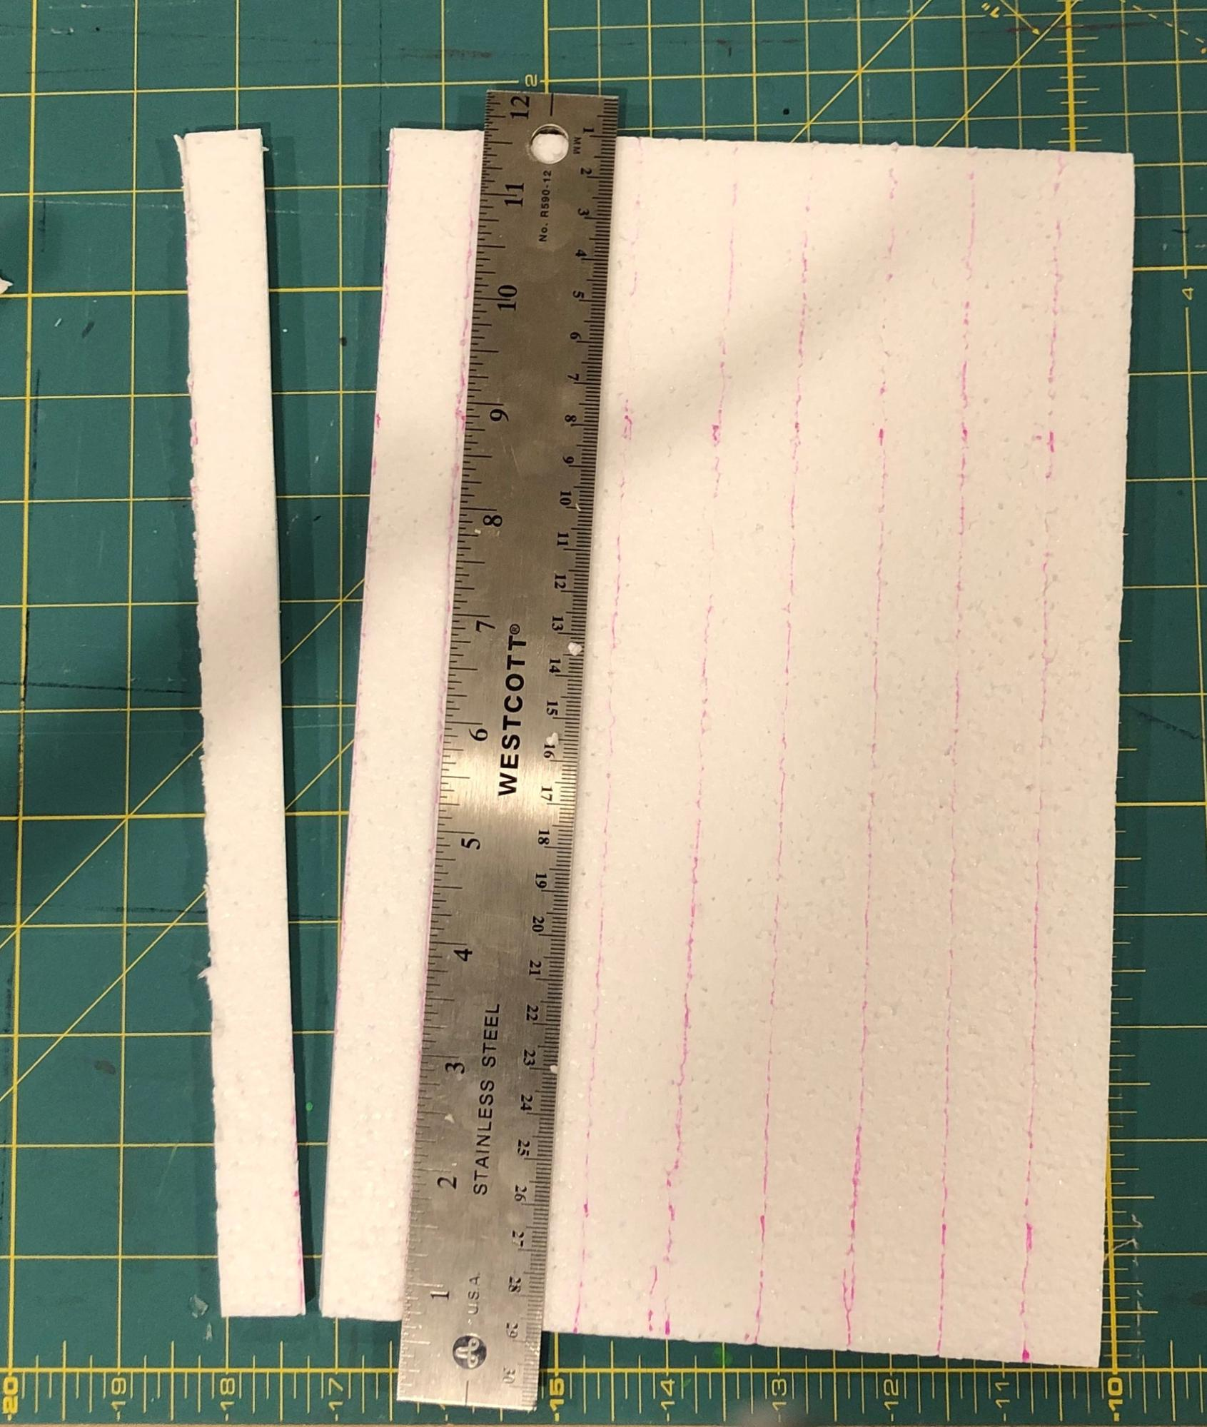
Day 1: Material Deformation Lab
- Group size: 3 students
- Setup
- Prepare strips of ¼”-thick Styrofoam by marking lines 2 cm apart down the length of 8.5 x 11 inch long Styrofoam panels, making strips that are 11 inches long by 2 cm wide. Cut along the lines with a utility knife or box cutter, using the side of a ruler as a cutting guide.
- Place supplies in a common area for students to pick up: Styrofoam strips, wood stirrers, and transparent tape.
- Place two bricks, one ruler, and one push-pull spring scale (10 N) at each testing station.
- Note: if you run short of foam strips or wood stirrers, you can use any extra rice noodles from lesson 2 as a substitute material. Wood stirrers should break easily under 10N, if they are 4 mm or less thick. In recent years, some manufacturers have started producing thicker wooden stirrers (6 mm of more) in response to customer complaints about the flimsiness of the earlier 4 mm thick versions. These thicker wooden stirrers may have a breaking above 10N, which is above the upper limit of your push-pull spring scale. You can still use these stirrers however, if you reduce their width, but not their thickness nor length. You can reduce their width with scissors by cutting them down the length of their spine. This will reduce their breaking point (about in half). You can do the same thing with foam strips too, reducing their width when you cut them out to reduce their breaking point.
- Safety:
- Wear safety goggles or glasses during the setup, hands-on, and take-down segments of the activity.
- Never eat any food items used in a lab activity.
- Make sure all other fragile items are removed from the test area.
- Secure loose clothing, remove loose jewelry, wear closed-toe shoes, and tie back long hair.
- Immediately pick up any items dropped on the floor so they do not become a slip/fall hazard.
- Follow your teacher’s instructions for disposing of waste materials. Wash your hands with soap and water immediately after completing this activity.
- Disposal: Used wood stirrers and Styrofoam can be thrown away in the trash.
- Storage: All materials can be stored and reused indefinitely.

Lesson 4 • Where We Are Going and NOT Going

Where We Are Going

Most solid objects that are made of material that is relatively stiff don’t appear to exhibit elastic behavior when observed with the unaided eye. However, all solid objects are springy or elastic (up to a point,) and this can be determined through measurements at a different scale. When forces are applied to objects, they will change shape and will spring back to their original shape when those forces are removed as long as those forces don’t exceed an object’s elastic limit.

The elastic limit of an object is dependent on its material type and thickness. Once applied forces exceed that elastic limit, permanent deformation occurs to the object. This can be thought of as a type of damage. If external forces on the object increase further, they will eventually reach the breaking point of the object (where fracturing occurs). Different materials have different elastic limits and different breaking points.

The relationship between the force applied to an object and the amount it deforms when it exhibits elastic behavior is linear for all solid objects. The slope of this relationship is different for different types of materials. For example, a 1-cubic-inch cube of rubber will deform 0.0001 inches per 1 lb. of compression force applied to it, steel will deform 0.0001 inches per 30,000 lb. of force applied to it, and diamond will deform 0.0001 inches per 1,700,000 lb. of force applied to it.

The region of elasticity of all solid objects helps explain why objects push back on things that push on them. It provides a mechanism for explaining why objects in contact exert equal and opposite forces on each other, why collisions can cause changes in motion in the objects that collide, and why objects are damaged in some cases but not damaged in others.

Working with linear and nonlinear relationships is a target of one element of the SEP for analyzing and interpreting data in the middle school grade bands. It is also a target of the CCMS in 8th grade. This lesson is the first introduction to working with linear and nonlinear relationships in graphs in OpenSciEd. Students will revisit the use and development of other linear and nonlinear models for data they collect later in this unit and in subsequent 8th grade units, such as OpenSciEd Unit 8.2: How can a sound make something move? (Sound Unit) and OpenSciEd Unit 8.3: How can a magnet move another object without touching it? (Magnets Unit).

This lesson leverages students’ experiences with planning an investigation where they identify an independent and a dependent variable and variables to keep constant. A standard structure on the handout for planning an investigation and identifying variables in this lesson is one that students will have used in prior OpenSciEd units. That should help make the investigation planning in this lesson a very familiar process. Even so, you will build an anchor chart as a reference for that planning process since this is the first lesson in 8th grade where students will have encountered it, and it will be useful for them to refer to in future lessons (e.g., the next lesson) and across all subsequent 8th grade units in the OpenSciEd sequence.

Where We Are NOT Going

The linear relationship between force and deformation is not a disciplinary core idea. The spring-like behavior of solids should be considered an important concept as it is cited in the Framework for NGSS: “The role of forces between particles also begins to be discussed in grade 6--topics include the recognition that particles in a solid are held together by the forces of mutual attraction and repulsion (which act like springs)” (p. 237). This lesson, however, makes no attempt to address that there are forces between particles that make up solid matter.

The elastic limit of an object is not only dependent on its material type and its thickness but also on the cross-sectional area to which the compression or tension force is applied. No attempt is made to introduce this idea, which is connected to the ratio of stress to strain an object exhibits during elastic behavior (Young’s modulus of elasticity). Known values of the ratio of force vs. deformation for elastic behavior of known materials based on Young’s modulus of elasticity were derived for 1-cubic-inch samples in the shape of a cube for the table used in Deformation Results. Force vs. deformation data used in Deformation Results were extrapolated from machine-produced results in the graphs reported in Khlystov, N., Lizardo, D., Matsushita, K., and Jennie, Z. (2013). Uniaxial Tension and Compression Testing of Materials 3.032 Lab Report. Retrieved from http://web.mit.edu/dlizardo/www/UniaxialTestingLabReportV6.pdf.

Engineers typically graph force vs. deformation relationships using slightly different measures: stress vs. strain. Stress is the force per unit area. This is typically plotted on the x-axis of a graph, and the corresponding ratio of deformation to the original object’s length (strain) is typically plotted on the y-axis. One reason for this graphing convention is that it allows easier calculation of potential energy stored in the object, which can be done by integrating the area under the curve of stress vs. strain. Such calculations, however, are not a target idea in the NGSS in this grade band nor in high school. We wanted to make teachers aware, however, of the rationale for why in this lesson we flipped the axes on which force and deformation are typically displayed. The rationale is this: in this lesson, where force is the independent variable and deformation is the dependent variable, force is plotted on the x-axis and deformation is plotted on the y-axis, as per typical conventions when developing mathematical models of quantitative relationships.

Students are introduced to qualitative fitting of a trend line to a scatter plot of data in this lesson. No attempt is made in this or other 8th grade OpenSciEd units to introduce linear regression to find this line. This is beyond the expectations for 8th grade Common Core Standards in mathematics. No attempt is made to calculate the slope of this line, though the data in the data table on the last page of Deformation Results are derived from the slope of such lines.

LEARNING PLAN for LESSON 4
1 · NAVIGATION | 4 min
MATERIALS: None
Recall what we figured out. Say, In our last lesson, we looked at slow-motion videos of really rigid objects, used a glass and laser setup, and looked at a video of engineers testing a concrete beam. We figured out that even really rigid things can bend or change shape in collisions. We had some questions at the end of Lesson 3 about how any amount of force would affect solid objects.

Discuss ideas with a partner. Present slide A. Say, What were some of your ideas for how we could figure out if any amount of force would cause any solid object to start bending or to change shape? Turn and talk with a partner about the questions on the slide.
- What were some of your ideas for how we could investigate if any amount of force would cause any solid object to start bending or change shape?

Say, In the concrete beam investigation, we noticed the beam bending and then cracking and then breaking into a lot of pieces. How much force do you think it takes to bend or change the shape of any solid object any amount either permanently, like when it breaks, or temporarily, like when it bends and bounces back to its original shape?
- How much do objects deform before they break?
- How could we tell how much force it takes to deform objects, either permanently or temporarily?
Listen for ideas such as these:
- More rigid or thicker materials take more force to deform or break.
- Very small forces might not cause really rigid or thich objects to deform or break.
- We need a way to measure the amount of force applied to an object.
- We need to test different materials using different amounts of force.

Say, I have some materials that I brought in for us to use. Let’s see how we could use them to investigate some of the things you suggested.

2 · PLAN AN INVESTIGATION: MATERIAL DEFORMATION LAB | 7 min
MATERIALS: Material Deformation Equipment Demonstration
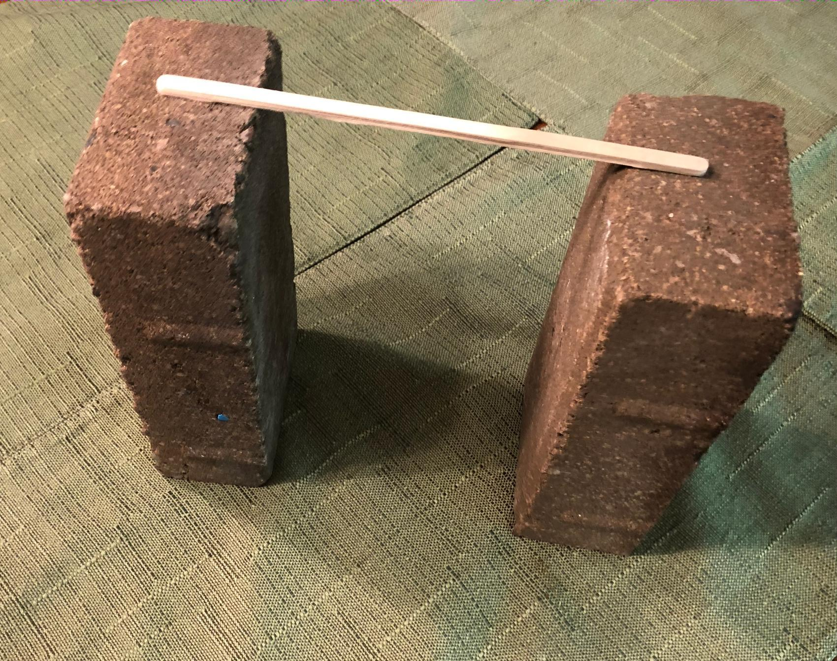
Introduce the materials and how they can be used for the investigation. Go through the process below with students standing around a demonstration table.

Show the bricks and how materials can be positioned to test how much they deform in a similar way to how the engineers tested the concrete beam.

Introduce push-pull spring scales. Say, We have a tool we can use to apply a certain amount of force to an object and measure how much force we are applying. This tool is called a push-pull spring scale. You may have seen similar scales used to weigh things like luggage, fish you catch, and produce at the market. Scientists, engineers, and others use tools like this to determine the amount of force they are applying to an object. Let’s see how these work.

ADDITIONAL GUIDANCE | Determine the mechanism for calibrating your push-pull spring scales. Before you pass these out, you may want to just double-check they all read “0” when they are held with the hook end down.

Pass around a push-pull spring scale to each group of two or three students.

Suggested prompt | Sample student response
Take one spring scale and push on the rod. What happens to the amount of force you feel when you push on it further? | It feels like more force back on you the further you push the spring in.
What do you notice about the numbers on the spring scale when you push on it with more force? | When you push it in further, you feel a bigger force and the numbers show a bigger number.

Introduce force units. Say, In science, when we use numbers to measure something, we like to include the units that we are measuring in, like meters, feet, seconds, and hours. Sometimes engineers measure the amount of force in pounds, and sometimes they use newtons. We will use newtons. Your push-pull spring scales have markings on them that range from zero to 10 newtons, or capital N. Let’s see how many pounds of force correspond to 5 newtons versus 10 newtons on the scale.

Demonstrate how the amount of force that registers on the push-pull spring scale (in newtons) corresponds to a similar change that would be registered on a digital scale measuring the force from the weight of an object on it. Demonstrate that pushing down with 5 N force results in a measured force that is the same as a weight of just over a pound (~1.1 lb.). Push down with a 10 N force and show that the weight on the digital scale doubles to about 2.2 lb.. Emphasize that both scales--the push-pull spring scale and the digital scale--are force measurement devices. | 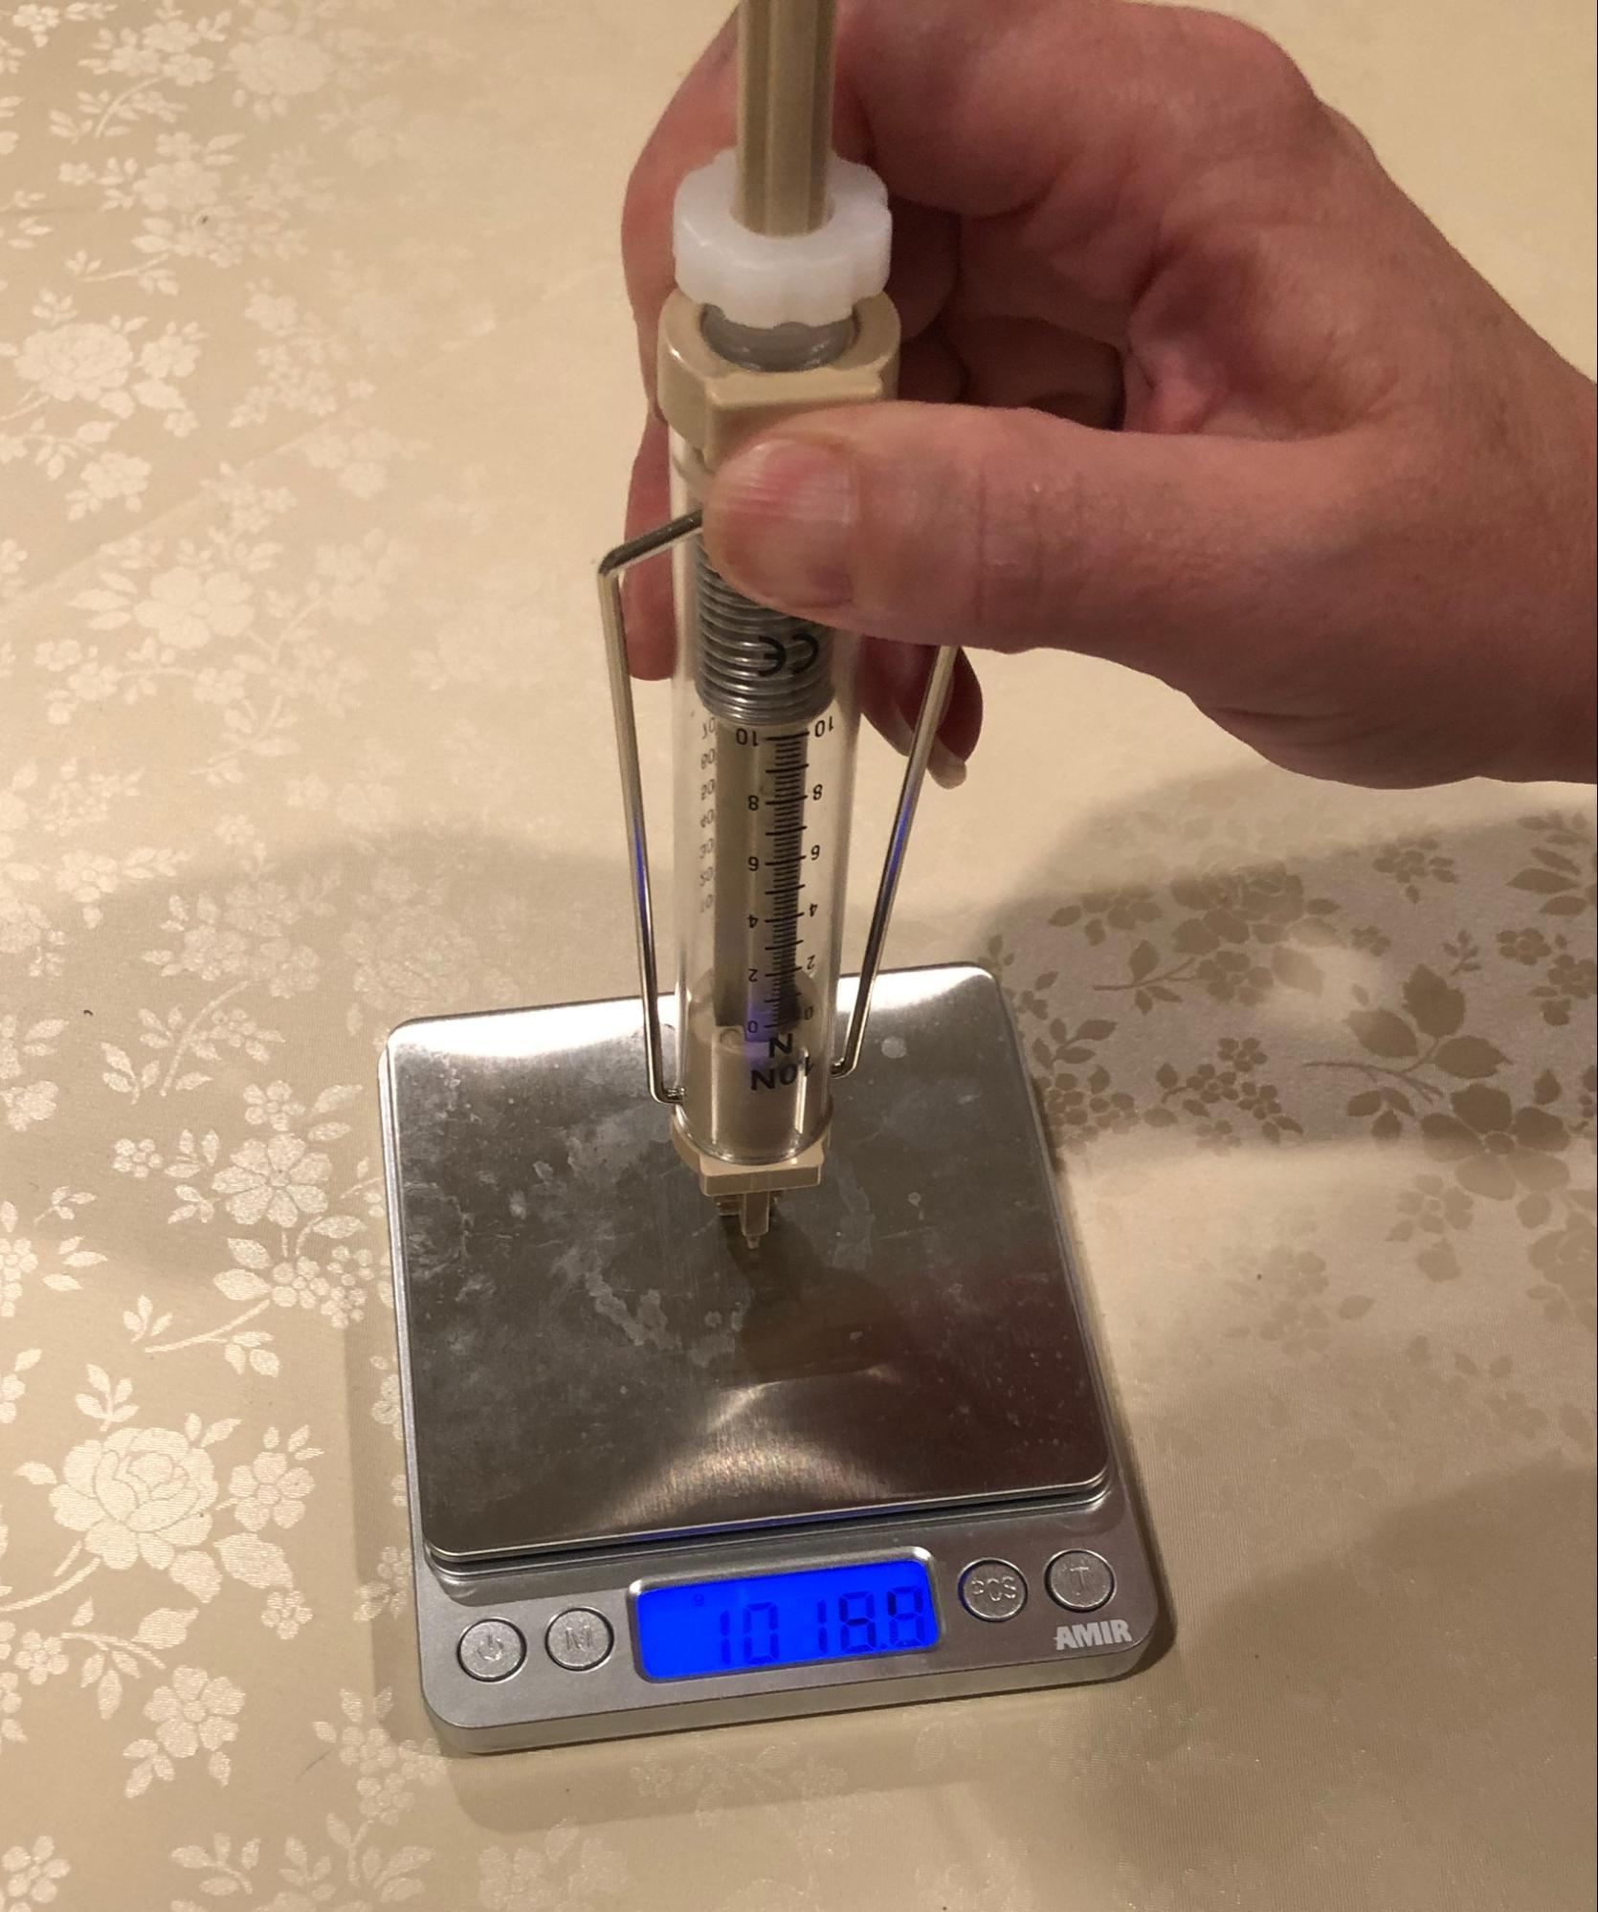
Explain that students can use this spring scale to apply more or less force to the object they are testing. Explain that you are going to demonstrate the kind of testing we could do with an example object: a 3-layer-thick beam of wood. Show the set of three wood stirrers that are taped together. Explain that different groups will be assigned different thicknesses of wood or Styrofoam strips to test in a manner similar to your demonstration. | 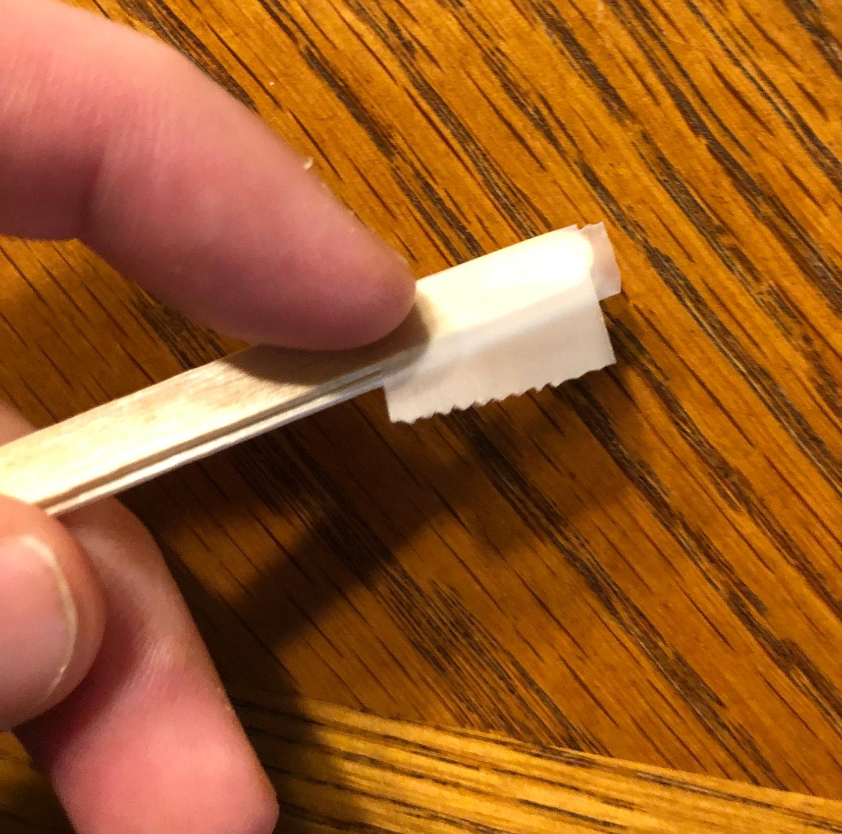
Place the 3-layer wood beam across the gap between both bricks. Tape down one end of the material to the brick surface. Place the push-pull spring scale on the 3-layer wood beam and push down with a 2 N force. Ask students what they notice. They should say the wood deforms. Show the ruler that can be used to measure how much the beam deforms.

Say, Let’s use what we’ve seen about this equipment so far to identify and document the variables in our experiment we want to change, measure, and control.

3 · IDENTIFY THE VARIABLES IN THE INVESTIGATION | 7 min
MATERIALS: Independent, Dependent, and Controlled Variables, Deformation Results, Investigation Procedures, science notebook, chart paper, markers
Identify the variables in the investigation. Distribute to each student a copy of Independent, Dependent, and Controlled Variables and Deformation Results. Have students take these back to their seats and tape both in their notebooks. Continue planning the rest of the investigation together as a class.  Ask students to record the investigation question, How much do you have to push on any object to get it to deform (temporarily vs. permanently)?, on their copy of Independent, Dependent, and Controlled Variables. Project slide B.  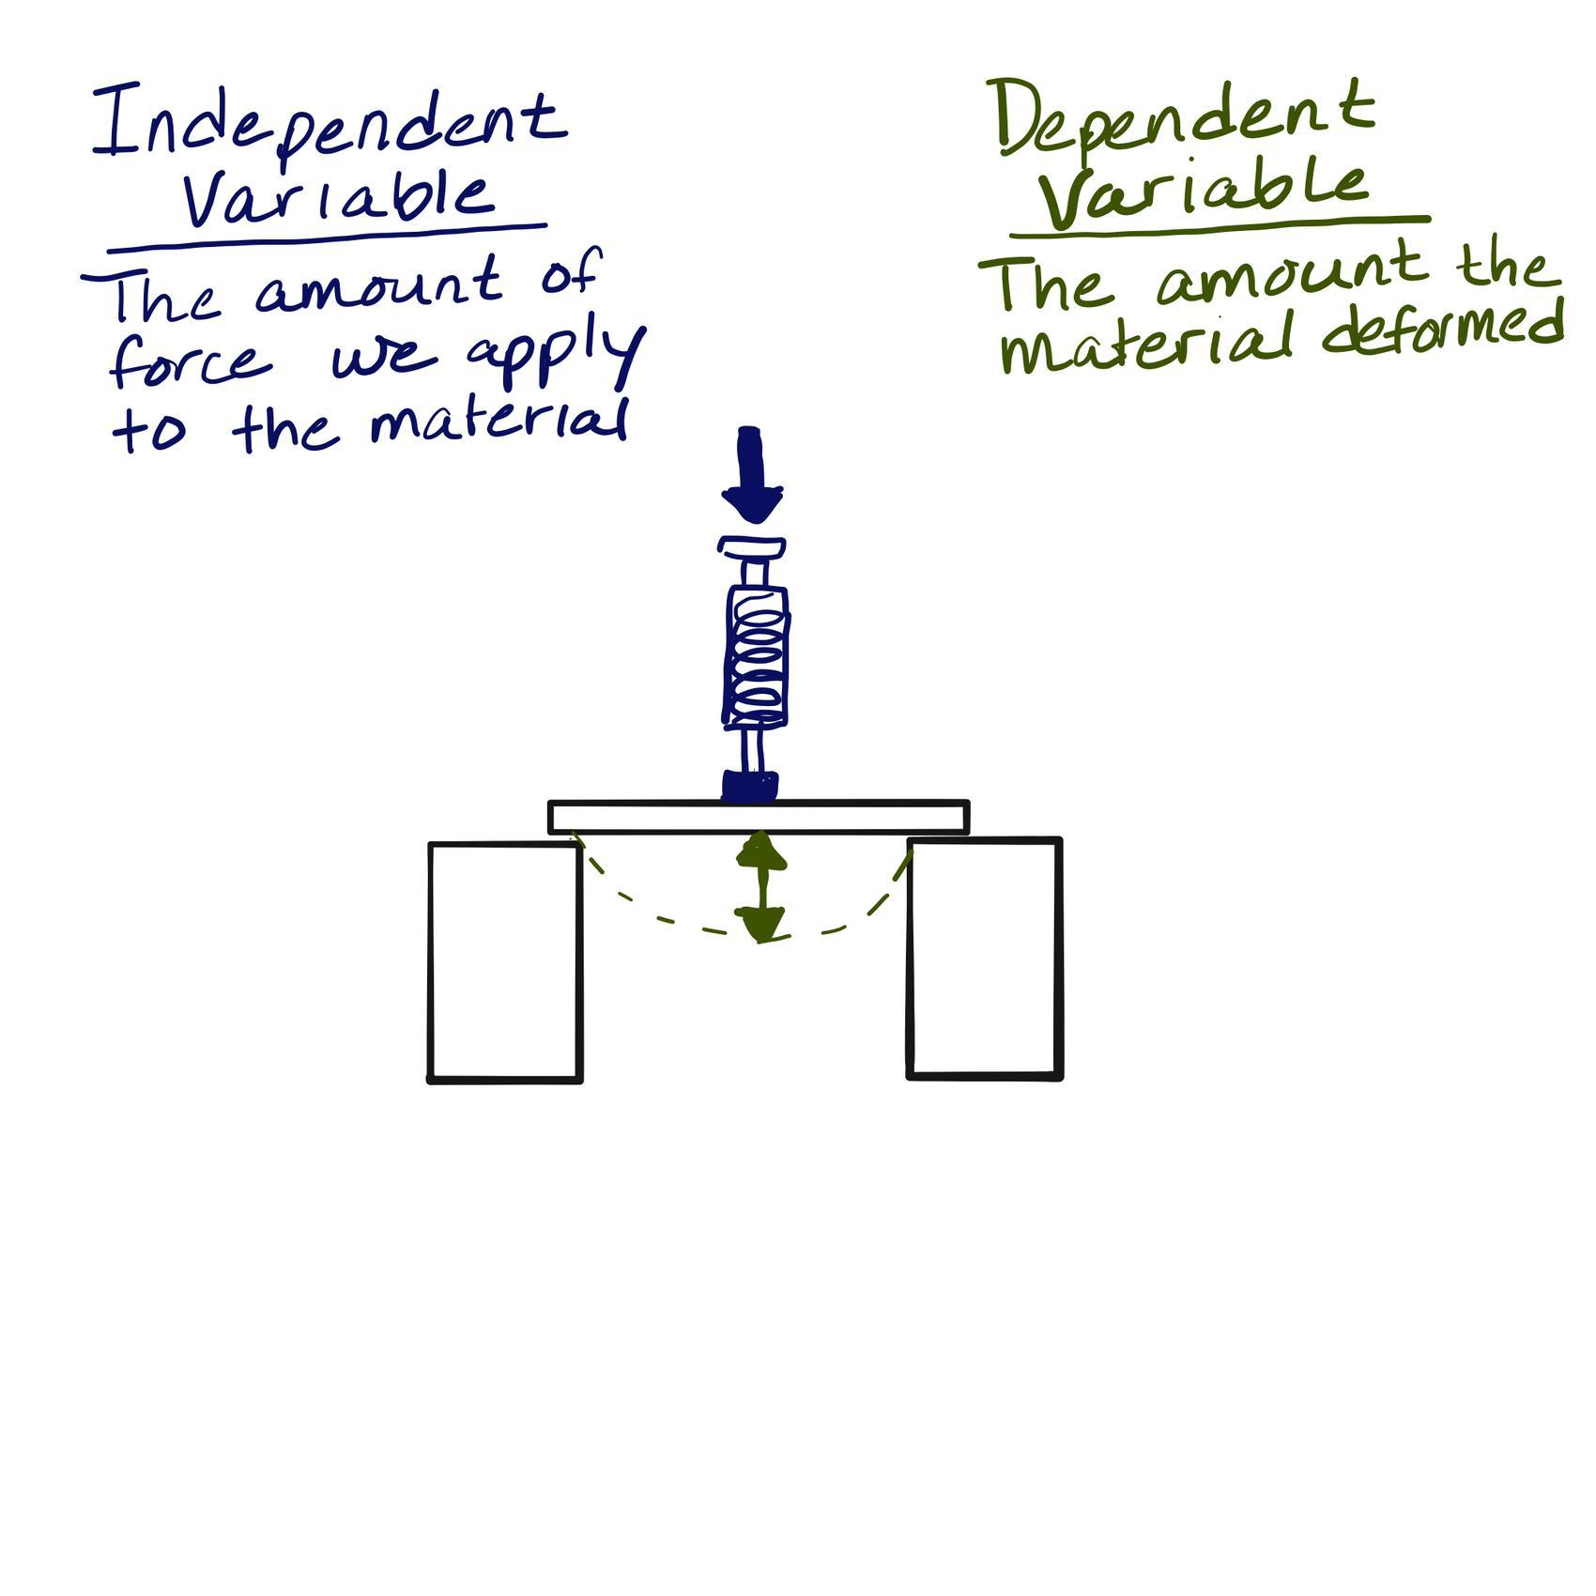  Draw on chart paper a sketch of the beam between two bricks they will be testing.  Discuss what the independent and dependent variables would be for this experiment. Review what independent and dependent variables are in general, as needed, using the text on Independent, Dependent, and Controlled Variables.  Add these definitions to the Word Wall:  - Independent variable--this is the variable to change each time you test.  - Dependent variable--this is the variable to observe the effects caused by a change in the independent variable.  Add this supplementary text in a different color, if needed, to further explain the variables:  - Independent variable--this is the variable to change each time you test. This is what you are manipulating in the experiment.  - Dependent variable--this is the variable to observe the effects caused by a change in the independent variable. This is the results variable.  Ask students what the independent and dependent variables are for this investigation. Students should say that the independent variable is how much we push on an object or the amount of force applied and that the dependent variable is how much it deforms. Add this to the anchor chart. Have students record these as the independent and dependent variables for their investigation.  Remind students that we have a way to measure the amount of push by reading the amount of newtons on the push-pull spring scale. Ask for ideas about how to measure how much the object bends or deforms. Help students narrow in on the idea of recording the height of the beam before and after they push on it.  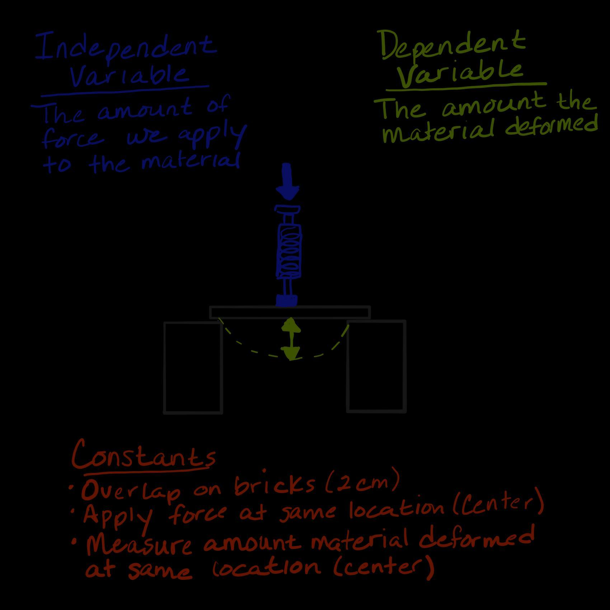  Discuss some things that would be important to keep constant in the investigation and add them to the experimental setup diagram. If students don’t suggest the placement of the object and the scale as things to keep constant, ask if the location of the spring scale on the material would affect the results and if the distance between the bricks and the amount of overlap of the material on the bricks would affect the results. Suggest that all groups test their objects in the center of the beam and make sure that their beams overlap the bricks by the same amount. A 2- or 3-cm overlap is suggested. Whatever you pick as a class, write the measurement on the anchor chart. Have students record these variables to keep constant on their Independent, Dependent, and Controlled Variables handout.  Post and save a copy of this anchor chart for students to refer to in this unit and future units.✱  Assign groups their materials to test. Have students record which material you assigned them to test above their data table on Deformation Results. The different options are as follows: a single wood stirrer, two wood stirrers stacked together, a single Styrofoam strip, or two Styrofoam strips stacked together. Tell groups to replace their materials with extras of these if after a test, it shows evidence of permanent deformation but has not yet cracked or broken into separate pieces.  Distribute Investigation Procedures to students. Project slide C. Tell students to use the procedure described on the Investigation Procedures handout to record the data from their investigation on the Deformation Results handout. Give students a couple of minutes to look through the procedure and then ask if there are any questions. | ✱ SUPPORTING STUDENTS IN ENGAGING IN PLANNING AND CARRYING OUT INVESTIGATIONS  Students will be planning other investigations by identifying these variables in future lessons in this unit and in other units in this grade. Having an anchor chart and their copy of Independent, Dependent, and Controlled Variables will be a helpful reference to serve as an example to work from as needed, for the remainder of their investigation plans at the start of the year.  If students are struggling with the ideas of variables, you may need to review some examples from previous investigations they have done in prior years. OpenSciEd units will have multiple examples to draw from in the following units:  - OpenSciEd Unit 6.2: How can containers keep stuff from warming up or cooling down? (Cup Design Unit)  - OpenSciEd Unit 6.3: Why does a lot of hail, rain, or snow fall at some times and not others? (Storms Unit)  - OpenSciEd Unit 7.1: How can we make something new that was not there before? (Bath Bombs Unit)  - OpenSciEd Unit 7.3: How do things inside our bodies work together to make us feel the way we do? (Inside Our Bodies Unit)  - OpenSciEd Unit 7.4: Where does food come from, and where does it go next? (Maple Syrup Unit)
  ASSESSMENT OPPORTUNITY | Building towards: 4.A Plan an investigation, identifying controls to keep constant, and carry out the investigation to produce data to serve as the basis for evidence to develop a mathematical model for the relationship (pattern) between the amount of force applied to an object and the amount it deforms.  What to look/listen for: Look for students to do the following in the planning of the investigation:  - identify the independent variable as the amount of force applied to an object,  - identify the dependent variable as the amount of deformation in the object, and  - identify control variables, including where the force is applied and how much of the object overlaps the two supports (bricks) in each test.  What to do: If students are struggling with the ideas of variables, you may need to review some examples from previous investigations they have done in prior years. OpenSciEd units will have multiple examples to draw from in the following units:  - OpenSciEd Unit 6.2: How can containers keep stuff from warming up or cooling down? (Cup Design Unit)  - OpenSciEd Unit 6.3: Why does a lot of hail, rain, or snow fall at some times and not others? (Storms Unit)  - OpenSciEd Unit 7.1: How can we make something new that was not there before? (Bath Bombs Unit)  - OpenSciEd Unit 7.3: How do things inside our bodies work together to make us feel the way we do? (Inside Our Bodies Unit)  - OpenSciEd Unit 7.4: Where does food come from, and where does it go next? (Maple Syrup Unit)

4 · CARRY OUT THE MATERIAL DEFORMATION LAB | 12 min
MATERIALS: Material Deformation Lab, Independent, Dependent, and Controlled Variables, Deformation Results, Investigation Procedures, science notebook, impact goggles
Monitor lab work.✱✱ Check that groups are involving all members in the data collection. This is a lab that requires different roles in the data collection process, such as the following:  - someone to apply a given amount of force  - someone to measure amount of deformation and whether the material becomes permanently deformed or returns to its original shape after the force is removed  - someone to record these results to share with the other group members after all data are collected  Ask students to wait on graphing their data until all groups have completed collecting their data. | ✱ SUPPORTING STUDENTS IN ENGAGING IN PLANNING AND CARRYING OUT INVESTIGATIONS  Encourage students to make careful observations and measurements in this investigation as they will be graphing their data to look for patterns that serve as evidence for cause-and-effect relationships among the amount of applied force, the type and thickness of the tested material, and the resulting permanent or temporary deformation.  ✱ SUPPORTING STUDENTS IN DEVELOPING AND USING STABILITY AND CHANGE  As students work, probe their thinking about the relationship between the type and thickness of the material tested and the amount of force needed to cause both permanent and temporary deformation. Listen for ideas about the elastic nature of different materials and how they can remain stable and return to their original shape but only to a point. Students should recognize that even small amounts of force are causing elastic deformation (stability) in these materials, and then when enough force is applied, these materials deform permanently (change).

5 · CONSTRUCT AND COMPARE GRAPHS | 10 min
MATERIALS: Deformation Results, ruler (or straight edge like a wood stirrer), science notebook, Example Line of Best Fit
Assign new pairs of students to work together. Pair each student so that they are working with someone with results from a different material testing group (either a different material or a different thickness of material or both).  Motivate determining common axis values. Say, In order to compare data between you and your partner, each of you is going to have to use the same intervals on your x-axis. And you are going to need to use the same intervals on your y-axis. To determine what those should be, first look at the maximum value for each of those across both of your sets of data. Then, talk about how you can stretch out your axis to use as much of the graph paper as possible and still have room to plot the maximum x value and maximum y value. Each person only needs to plot their own data set, but both of you need to set up the same agreed-upon set of intervals for your axes before you plot your data. When you plot your data, be sure to use an open circle anywhere the beam returned to its original shape after the weight was removed, use a closed circle anywhere the beam was damaged from the weight that was added, and use an “x” at any point where your beam cracked.  Observe Deformation Results for how students develop their graphs.  Introduce the additional data that were collected. Say, Next I want us to talk about how we can develop a mathematical model of the relationship you see in your data. I have a set of data for us to look at together to help us think about how to do this.  Project slide D. Explain that the data on the slide were collected from three wood stirrers taped together. Emphasize that for every data point, the object returned to its original shape and position after the force was removed. Give students a minute to look at the graph and then ask them to share what patterns they notice.✱  Describe what a trend line is and how to make one. Say, When you have multiple data points and some of them are for the same value you plotted for your independent variable, it can be helpful to plot all that data on a coordinate graph like we’ve done here. What we end up producing is sometimes called a scatter plot. Because we haven’t averaged any of our results yet, it can be useful to think about what the average trend in all of the data is. One way to do this is to create a trend line to show how close the data are to a linear relationship. Constructing a trend line can be done by holding up a ruler or straight edge over the graph and shifting its angle and position so that the slope and y-intercept of the line it would make is as close as possible to all the data points on the graph. This line may pass through some of the points, none of the points, or all of the points. The key is to try to fit the line as closely as possible to the average trend in the data.  Compare lines of best fit. Project slide E. Ask which line is a better fit to the average trend in the data. Students should say line C.  Say, This trend line is also sometimes called the “best fit line” or “line of best fit”. It helps us see that the data might be closer to a linear relationship than we suspected at first. If we collected and graphed additional data, this line also shows our best estimate of where we would expect that additional data to fall.  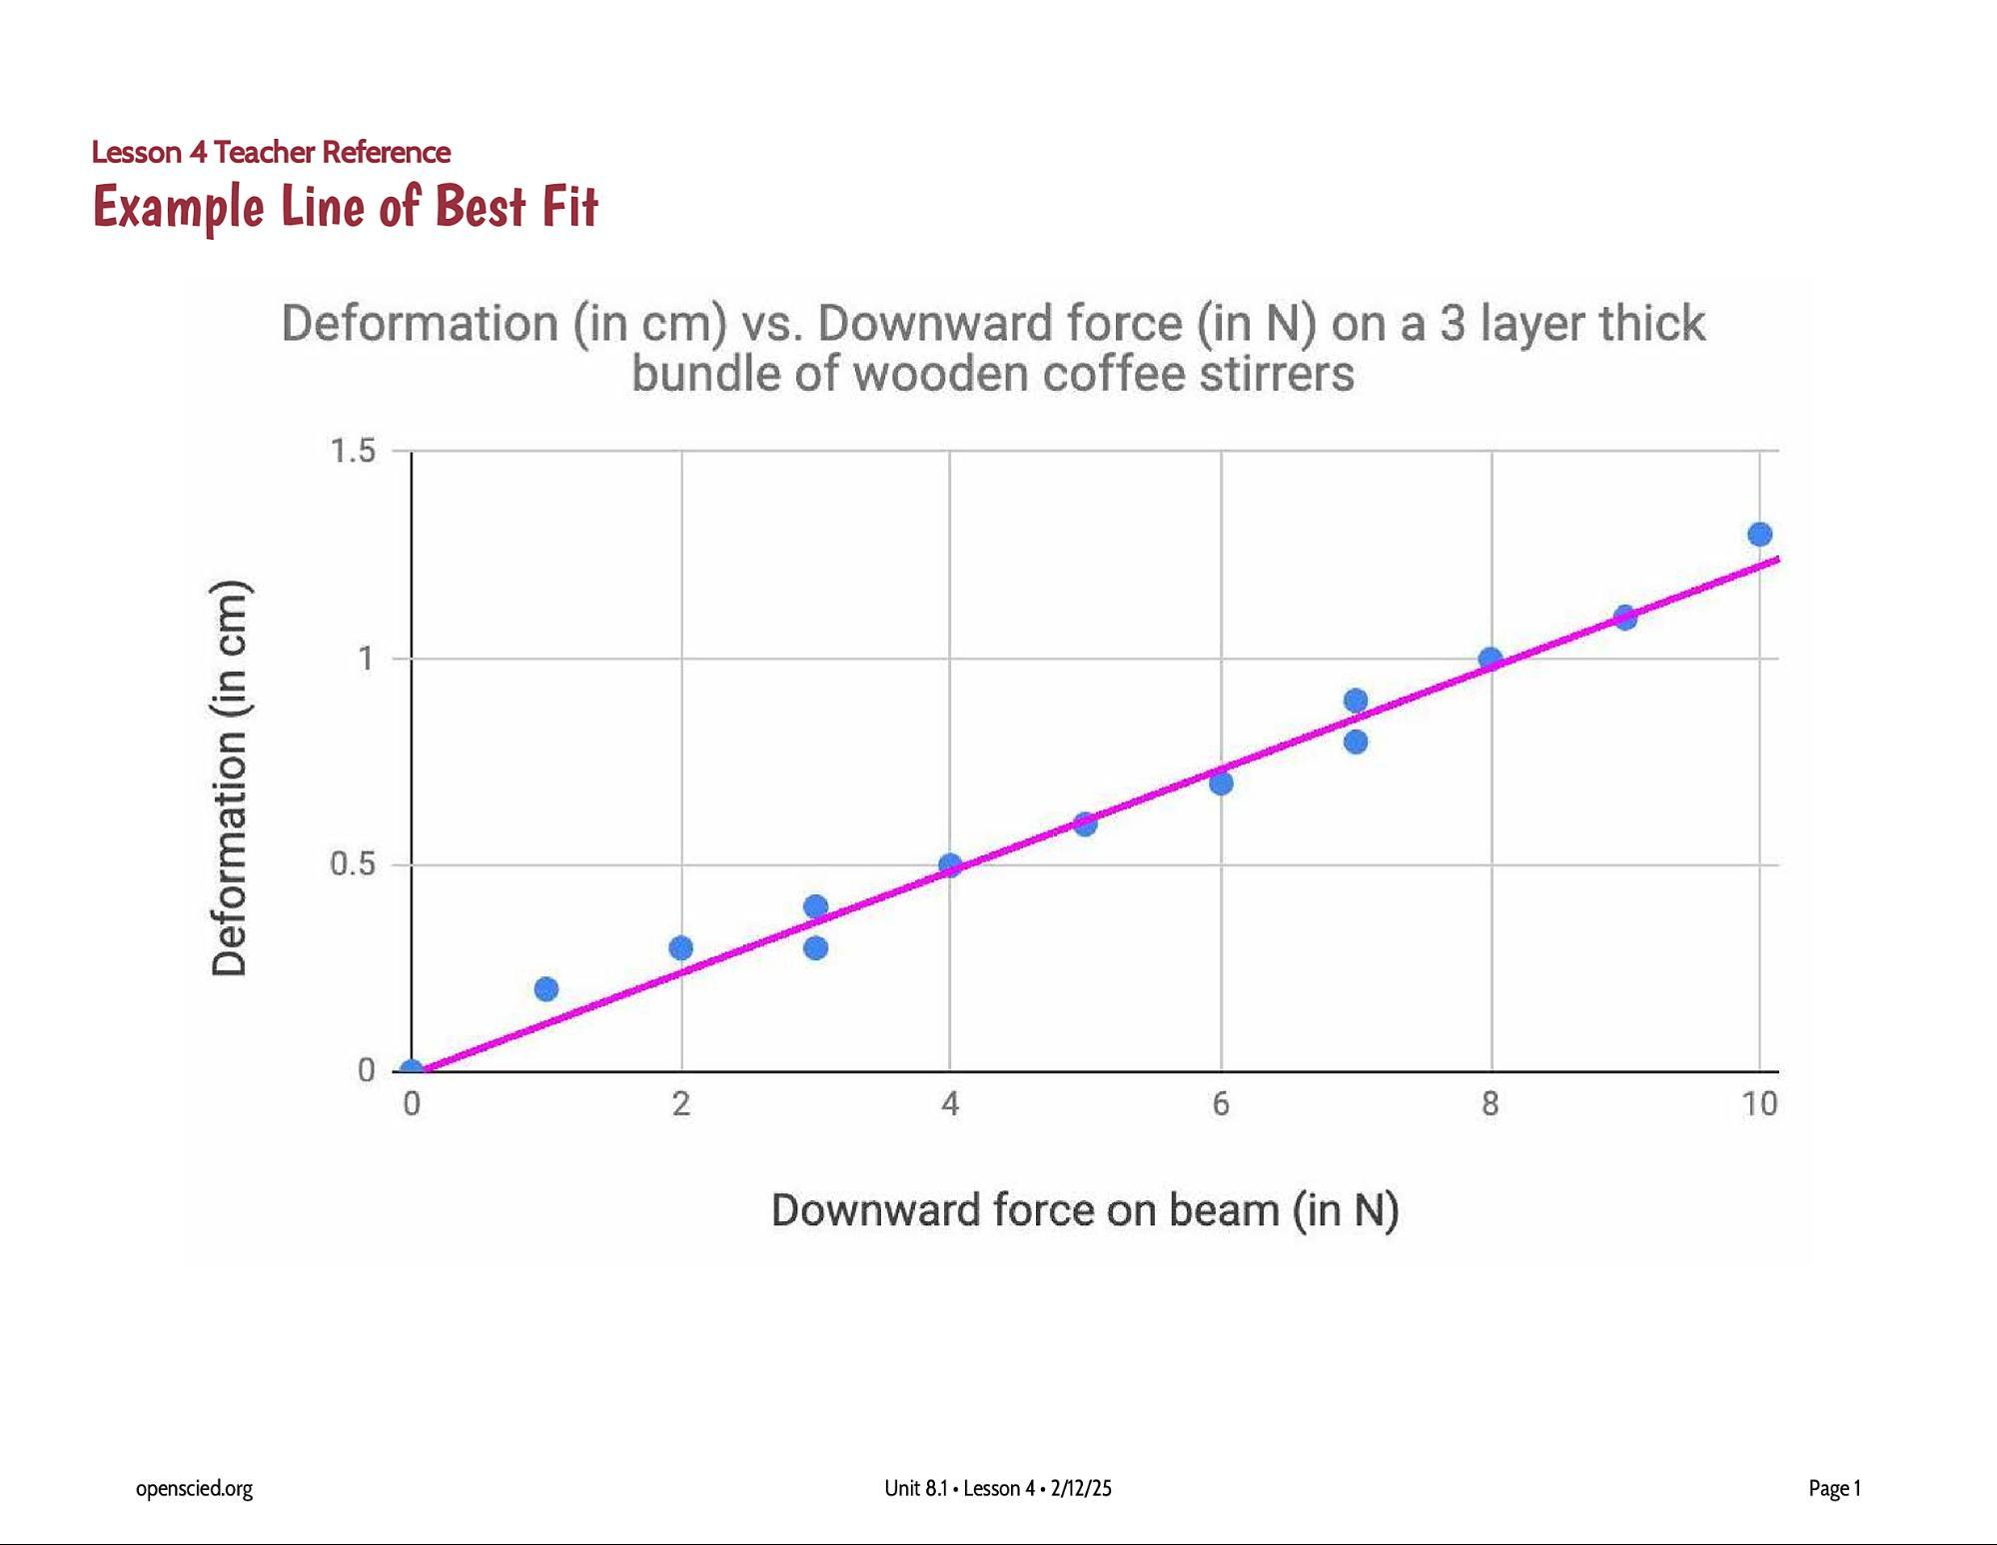  Post a copy of Example Line of Best Fit on the Word Wall. Remember to cover this posting or remove it before your next class.  Instruct students to use an extra sheet of paper to cover the data points on their graph that represent when the object showed evidence of permanent deformation (these data points will be a solid circle or an “x”). Students should be looking at only the data points that are represented with an open circle on the graph.  Construct trend lines for the data that students collected. Tell students, Sometimes data that don’t look that linear end up looking much more so after we draw a best fit line. Let’s see what that looks like for your data now. Show slide F. Give students a minute to construct on Deformation Results the best fit line for their own data using a ruler (or wood stirrer) and a pencil or pen. Emphasize that students should only be considering the data points that are represented with an open circle on the graph. | ✱ SUPPORTING STUDENTS IN ENGAGING IN ANALYZING AND INTERPRETING DATA  By 8th grade students should be able to construct, analyze, and interpret graphed data and identify linear and nonlinear relationships. Ultimately, students should identify patterns in data to develop cause-and-effect relationships about the amount of force applied to an object and the amount of deformation that results from the applied force. Students should be able to explain the meaning of trends they notice in their data as well as what an individual data point represents.
  ASSESSMENT OPPORTUNITY | Building towards: 4.B.1 Analyze and interpret graphical data (patterns) from tests of compression force vs. amount and type of deformation (effect) to provide evidence that supports an argument that all objects behave elastically up to a specific limit beyond which permanent damage occurs.  What to look/listen for: student graphs should include the following:  - the x-axis labeled as the force applied to the object (in N)  - the y-axis labeled as the amount of deformation in the object (in cm)  - stretching out the intervals to maximize the use of the graph paper while still capturing the highest x value and highest y value  - equal intervals identified on each axis  - a straight line of best fit through the data that are represented with points drawn as open circles (anywhere the beam returned to its original shape after the weight was removed)  What to do: Since this may be the first time students have drawn a trend line in 8th grade, talk with your math teachers in 8th grade to determine when students will be encountering this idea in their math class. It is a CCMS target learning goal for 8th grade.  If students struggle with these graphing skills, coordinate with the grade-level math teacher to ask about additional contexts that students may be familiar with from math class that they can practice applying these skills to. These examples can be a useful reference for students. You may want to post these as anchor charts in your class to help students see how to transfer to their science class the ideas and skills they are developing in math.
  Suggested prompt | Sample student response
  What patterns do you notice in the data? | The data look a bit scattered.
  What tends to happen to the amount of deformation as the amount of force applied to this object increases? | It tends to increase.
  Where on the graph do we see evidence of having recorded more than one deformation measurement for a certain amount of force? | At 3 N.  At 7 N.
  ADDITIONAL GUIDANCE | Universal Design for Learning: Students with high interest in materials science or engineering may be curious to learn more about how other materials deform in response to contact forces. For those students, you can encourage them to test other materials or objects at home and bring in a graph to share with the class what they found. Other materials that are easy to collect data from include strips of cardboard and plastic rulers.

6 · NAVIGATION | 3 min
MATERIALS: Deformation Results
If time is short you may need to skip this step and related Turn and Talk.

Project slide G. Ask, Do you think the trend in your data will be similar to or different from the trend in data from other groups? Why or why not? Students will likely compare their graph to their partners in this discussion. Give students time to do this during this Turn and Talk and tell them they will have a chance to compare with all the other groups next time.

End of day 1

7 · NAVIGATION | 5 min
MATERIALS: Deformation Results
If you had time for students to do the Turn and Talk at the end of the previous class, say, At the end of our last class you drew lines of best fit for your group’s data and may have had time to compare it to one other group. Let’s see how it compares to the rest of the groups.

Groups discuss findings in a jigsaw activity. Project slide H. Ask all students who investigated a single wood stirrer to raise their hand. Count off by number and have them remember their number. Do the same for the students who investigated two wood stirrers. Do the same for those who tested single Styrofoam strips. Do the same for double Styrofoam strips.

Instruct students to relocate to meet with all the members of the class who have the same number as them. Give students about 3 minutes in these groups to compare and discuss what they notice in the different graphs.

Pause small-group discussion and ask 2-3 groups to share similarities or differences they noticed across all the graphs in the group and then say, Just like the concrete beam data we saw earlier, scientists have studied other materials. Let’s see how the patterns in our data compare to data collected by engineers when they tested different metals.

8 · GATHER INFORMATION | 12 min
MATERIALS: Results from other materials tests, science notebook
Make predictions. Project slide I. Read the text on the slide. Point out that the compression machine described is shown in the photo. Have students turn and talk about their predictions. As students are doing this, hand out a copy of Results from other materials tests to each student.

Introduce the context of the reading. Emphasize that Results from other materials tests will summarize the results from the materials testing predictions they made with a partner. Project slide J. Instruct students to read and answer the questions on Results from other materials tests individually. Tell them that you want to collect this at the end of the period and that the last instruction in the reading is to update their individual Progress Trackers. Tell students that they should include anything they figured out from the lab and the reading that helps answer our lesson question when they get to that point as we are going to share our discoveries in a Scientists Circle after this.

Give students the remaining activity time to work on this individually.

ADDITIONAL GUIDANCE | Extension Opportunity: Students with high interest in materials science or engineering may be curious to learn more about how other materials deform in response to contact forces. For those students, you could provide an opportunity to research how the modulus of elasticity, yield strength, and ultimate tensile strength are related to things like the linear region of the force vs. deformation graphs, the elastic limit, and the breaking point on the graphs.

9 · ADD TO OUR PROGRESS TRACKER | 15 min
MATERIALS: science notebook
Lead a Consensus Discussion. Project slide K. Have students prepare a two-column Progress Tracker and record the lesson question in it.  Relocate in a Scientists Circle. Remind students that we first started researching this question by looking at slow-motion collision videos of cars, a baseball bat, and a golf ball. Ask students what additional sources of data we used to investigate this question since then. Students should recall four other sources of data. Help students agree on this list to add to their class Progress Tracker:  - slow-motion videos of collisions  - laser light reflected off a mirror on a piece of glass  - concrete beam load video  - force vs. deformation lab results (wood and Styrofoam)  - compression test results from engineers  Shift to co-developing a list of key ideas that we figured out from our work with these sources of data. Have students look back at what they wrote in their individual Progress Trackers for ideas. Use prompts similar to these, inviting students to contribute ideas and to work with the ideas that others contribute:  - Who can suggest one idea we should add to our Progress Tracker about how materials respond when a force is applied to them?  - Is this true for all solids? How do we know?  - Can someone summarize an important idea about what it means when we say solids are elastic up to a point?  - If all materials are elastic up to a point, what is the difference between a rigid material like steel or glass and something that is more flexible?  - Does someone have an important idea about elastic limits or breaking points related to forces that we haven’t included yet in our class Progress Tracker?  Use follow-up prompts, such as Do you agree? and Did anyone say the same idea in a different way?, to encourage students to voice agreement on ideas.  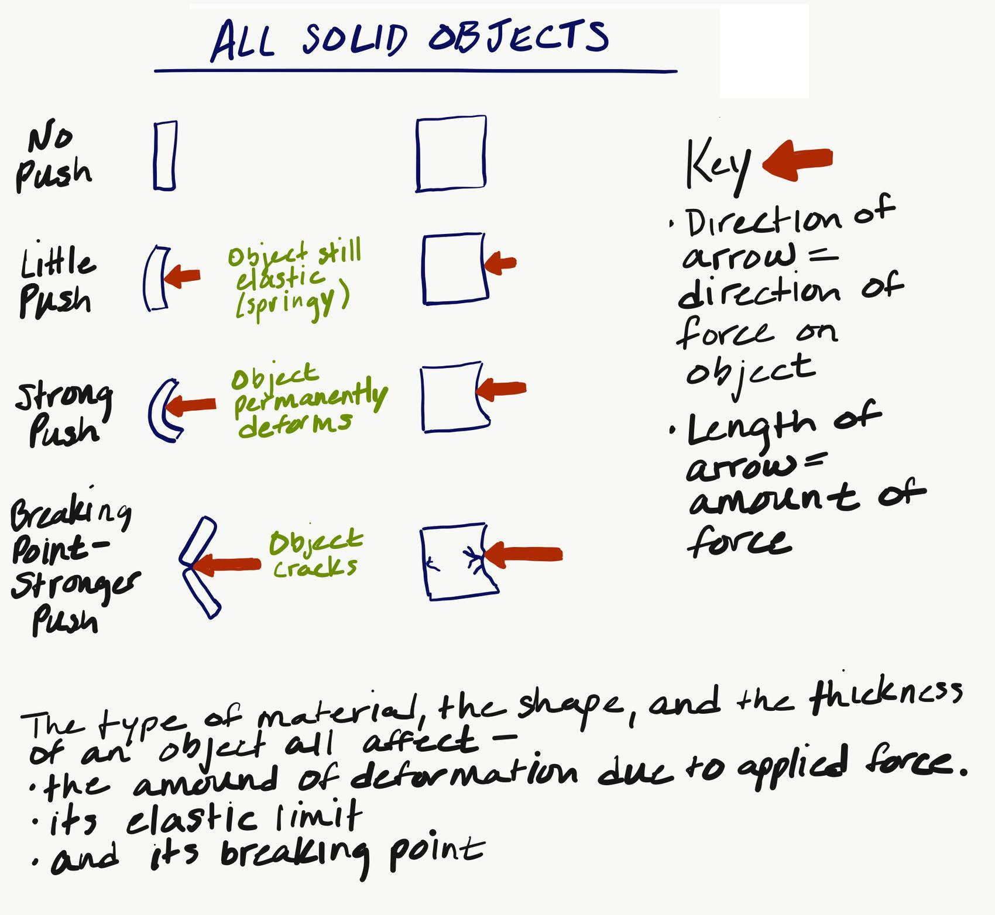  In addition to a summary of the ideas listed in the “What we figured out” section, have students add to their Progress Trackers a visual representation of the ideas like the one shown here. Invite students to explain how these ideas help us answer our lesson question.✱ Use prompts like these:  - Can someone summarize how these ideas help us explain why some contact forces damage objects and others don’t?  - How could these ideas help explain why some collisions might cause damage and others don’t?  Listen for student responses related to the amount of force applied, the amount of deformation that it causes in the material, and whether the force exceeds the elastic limit of the object and/or its breaking point. | ✱ SUPPORTING STUDENTS IN DEVELOPING AND USING PATTERNS  Students will have evidence of repeating patterns from their own investigations and from the investigations of other scientists. These should help them develop cause-and-effect relationships describing how contact forces can cause objects to break in some cases and not in others. This is an important sensemaking step in the progress toward student understanding of the anchor phenomenon.
  KEY IDEAS | Purpose of this discussion  - Summarize the main ideas about how solid objects respond to forces applied to them and how their elastic limits and breaking points are affected by the material they are made of, their shape, and thickness.  Listen for and have students make note of these ideas on their Progress Tracker:  - From previous lesson: All solid objects bend or change shape in a collision and when other contact forces are applied to them.  - All solid objects deform elastically when smaller amounts of force are applied to them; they will spring back to their original shape when this force is removed.  - How much a solid object deforms for a given amount of force applied to it is dependent on the type of material it is made of, its shape, and its thickness.  - Different objects have a different  - elastic limit = the maximum amount of force or deformation they can withstand, beyond which they will deform permanently.  - breaking point = the maximum amount of force or deformation they can withstand, beyond which they will crack or split apart.

10 · ARGUING FROM EVIDENCE | 10 min
MATERIALS: science notebook
Say, We figured out a lot today about the deformation of materials due to forces, and we know that there is a force in a collision. Let’s see if we can use these ideas to evaluate the claims that a company has recently made about creating an unbreakable screen for a phone.  Argue from evidence. Project slide L. Ask students to use a piece of paper to quickly demonstrate and explain how this might be possible with a partner. Give students 2 minutes to talk. Look for students to fold or roll the paper without creasing it. Say, In your notebooks, write an argument to share your thinking about this claim that there is a foldable phone that has an unbreakable screen. Support your argument using evidence from all our investigations so far.✱ At the end of this activity, collect science notebooks to review student responses. | ✱ SUPPORTING STUDENTS IN ENGAGING IN ARGUMENT FROM EVIDENCE  This activity supports students in making an argument that supports or refutes the advertised performance of a device using evidence from their own investigations and the investigations of other scientists. This is also an opportunity for students to begin to think about the criteria and constraints that are important in the design of materials used to protect fragile things, which will be addressed later in the unit.
  ASSESSMENT OPPORTUNITY | Building towards: 4.B.2 Analyze and interpret graphical data (patterns) from tests of compression force vs. amount and type of deformation (temporary vs. permanent) to provide evidence that supports an argument that all objects behave elastically up to a specific limit beyond which permanent damage occurs (stability & change).  What to look/listen for:  - Students make claims and defend their thinking using evidence.  - Students are selecting and including multiple sources of evidence from their own and others’ investigations.  - Students are organizing evidence so as to be persuasive in support of their claim.  What to do: Use questions to help students to organize and link evidence in support of their claim and to consider strategies for arguing persuasively for the validity of their claim. Here are some examples:  - How does your evidence support your claim?  - Does your claim rely on any inferences or assumptions?  - Do you have enough evidence to support your claim?  - Is there evidence to support a claim that is counter to your claim?

11 · NAVIGATION | 3 min
MATERIALS: None
Motivate the next lesson. Say, We’ve been thinking about how forces cause the shape of any object to change. And in an earlier lesson we argued that there are forces involved in a collision. Let’s consider forces in collisions again. Think back to the slow-motion videos we analyzed. All of those situations we looked at involved one moving object and one motionless object before the collision. What about situations where both colliding objects are moving, like when a baseball bat and ball collide in a game of baseball? Does the bat hit the ball or does the ball hit the bat? What would be pushing on what? How about in the case of the golf club and golf ball?

Display slide M. Give students time to discuss the questions on the slide with a partner and tell them we will explore this further in our next lesson. Remember to collect Results from other materials tests.

Additional Lesson 4 Teacher Guidance

SUPPORTING STUDENTS IN MAKING CONNECTIONS IN ELA | CCSS.ELA-LITERACY.SL.8.1.C Pose questions that connect the ideas of several speakers and respond to others' questions and comments with relevant evidence, observations, and ideas.  CCSS.ELA-LITERACY.SL.8.1.D Acknowledge new information expressed by others, and, when warranted, qualify or justify their own views in light of the evidence presented.  Both of these ELA goals are the focus of the discussion in the Scientists Circle at the end of day 2 of this lesson when the class is working together to decide how to update their Progress Tracker. The focus on connecting questions, sources of evidence, what we observed, and key science ideas from other students in order to create an agreed-upon set of consensus ideas to add to the Progress Tracker relies on the first ELA goal above.

SUPPORTING STUDENTS IN MAKING CONNECTIONS IN MATH | CCSS.MATH.CONTENT.8.F.B.4 Construct a function to model a linear relationship between two quantities. Determine the rate of change and initial value of the function from a description of a relationship or from two (x, y) values, including reading these from a table or from a graph. Interpret the rate of change and initial value of a linear function in terms of the situation it models and in terms of its graph or a table of values.  CCSS.MATH.CONTENT.8.F.B.5 Describe qualitatively the functional relationship between two quantities by analyzing a graph (e.g., where the function is increasing or decreasing, linear or nonlinear). Sketch a graph that exhibits the qualitative features of a function that has been described verbally.  Both of these math goals are a focus of the end of day 2 of this lesson when the class is working together to determine a trend line for a set of data (material deformation due to compression force). Students make a similar line for the data they plotted in the previous class and compare this to the lines of best fit made for data sets from other groups. Students also compare graphs of linear relationships for the elastic behavior of other materials and nonlinear regions in the graph as well. They interpret the graph to identify the point that the elastic limit of the object is reached and it's breaking limit. They also interpret a table of values describing the slope of the line in a graph for the elastic behavior of the different materials as the ratio of material deformation in inches for a certain amount of compression force.

